Welcome to your spring newsletter

Take a look at what’s happening in the mhs community

Our first ever homeowner conference

Inside this issue:

Win a giant Easter egg!
Turn to page 4 for full details…

Survey: biodiversity and
green spaces near you p5

Real life story: “We had
to run for our lives” p6

Crossword competition p7

A WHOPPING 2.5kg Easter egg could be yours.
To be in with a chance of winning 2.5kg of delicious chocolate, complete our Easter themed crossword on page 7. 






What’s on over Easter p3
Have your say p2

mhs homes newsletter | spring 2025
1

Help us shape services and
Ready, set, grow!

have your say
We want to work in partnership with you to improve services. There are lots of ways to have your say, from being an estate champion to carrying out checks on our services or attending one of our customer conferences (read more on page 4).

By getting involved, you’ll meet new people, use your skills and develop new ones. Visit mhs.org.uk/get-involved to find out more. 

Who we are

mhs homes and Heart of Medway are part of the mhs homes group. We build and manage homes for people who need them most.
Visit mhs.org.uk to find out more about the work we’re doing in your community. 

Our gardening competition is back for 2025 and we can’t wait to see your entries!

It’s about celebrating your horticultural skills – whether it’s an amazing vegetable patch, a wildlife haven or a colourful sea of flowers.
No space is too small. If you’re proud of your plants and gardens, then we want to see them too.

How to enter
Get snappy with your camera or phone and send your best photos to Sue.Rudd@mhs.org.uk.

Get your entry in by Saturday 12 July. The winners will be announced on Friday 1 August at an awards ceremony at Broadside, Chatham.

For more information, visit

Meet Laurence, one of our estate champions
mhs.org.uk/gardening 


Laurence Ford has a passion for where he lives. He’s one of the estate champions working with us to make your estates and local communities cleaner, safer and more resilient.

Laurence has been an mhs homes resident for 11 years. He lives in Luton, Chatham, and describes
it as a thriving community where people really care about each other and their environment.

“We love living here, and we want
to protect it,” he explains. “My role as an estate champion is to keep an eye out for any issues, to listen to what other residents are saying and make sure our voices are being heard.

“People tell me about things like nuisance neighbours or fly-tipping and I make sure they are raised with the housing and estates teams at mhs.

“By shining a light on what’s happening, we can get problems sorted more quickly and avoid some of the frustrations.”
Laurence is modest about the difference he’s making, but as a builder by trade he takes a very practical approach to some of the issues that come up.

“It’s good to get out on the area walkabouts with mhs housing officers and local councillors so
I can explain what’s going on. I also get progress reports on how things we’ve raised are being dealt with.”

Laurence says he’d encourage other residents to take up the opportunity to become an estate champion.

“If you want to help make improvements where you live, this is the way to go. mhs homes teams can’t be everywhere, but by being involved and keeping
them updated, we can be part of the changes we want to see.” 

Spring has arrived and we’re looking forward to some warmer and sunnier days after the long winter. The Easter holidays are
What’s on over Easter
Are you paying
for care?
Are you a supported living resident who is paying for care through a care agency or a private carer? If so, please contact Tina at 07843 599077 or
Sue at 07843 599053.

We can help ensure you're receiving all the benefits you're entitled to or discuss arranging a care manager for you. 
a chance to get out and enjoy some of the fun-filled activities that are happening around Kent. Here are some of our top picks:

- Visit Maidstone Museum | Free
- Enjoy a picnic at Mote Park
Free
- Join the Lego club at your local library | Free
- Medieval Fayre, Maidstone
12 April | Free
- Broadstairs Food Festival
18 – 20 April | Free
- Buttercups Sanctuary for Goats
Entry is by donation
- The Shell Grotto in Margate
From £2

- Family special screenings at local cinemas | From £2.75
- Visit The Guildhall in Rochester
Free
- Easter Trail at Leybourne Lakes
18 April | £5 per child
- Bredgar and Wormshill Light Railway | From £7.50

  - Hadlow College Lambing Weekend | 26 – 27 April | From £10
  - Kent Life Easter weekend
18 – 21 April | From £11.70

Go to visitkent.co.uk for information on what’s happening in your area. 





mhs homes newsletter | spring 2025 mhs homes newsletter | spring 2025
2
3

Improving the
Your service
charge estimates
If you’re a leaseholder or shared owner, you will have received your service charge estimates by now. We’ve estimated how much servicing and maintaining
your block, communal areas and estate will cost in 2025-2026. The charge will be applied from 1 April.
At the end of the year, we’ll calculate what we actually spent

Understanding what biodiversity and green spaces mean to you
As a social landlord operating in

Meet your grounds team
We know our customers want to live in clean, safe and well-maintained neighbourhoods. Meet the team who are working to make places you’re proud to call home.

experience of homeowners
A big thank you to everyone who joined us at Chatham's Historic Dockyard in February for a conference aimed at improving the experience of homeowners.

You’ve told us we haven’t always got things right and you feel undervalued. The event is part of the work we're doing to listen to your feedback, address your concerns and improve services.

Some key themes included service charges, estates and grounds maintenance, communication and the time you spend waiting for communal repairs to be carried out at your home.

We’re listening to what you’ve told us and we’re making changes including:

- Improving our website so you can find what you need faster and easier
- More detailed and transparent information
- Training for contact centre staff so you get the answers you need first time without needing a call back
- Learning from repairs so we aren’t repeating work
- A more consistent approach to debt management and more support for homeowners
- More tailored information for on My Account, your customer portal
- Improving the quality and speed of responses to your complaints.
and if our estimate was higher, we refund you the difference. If the estimate was lower, you’ll be charged the difference.

Did you know you can arrange to spread the cost of your service
charges over a year by monthly direct debit?

To find out more, or if you need support with paying your service charges, please contact the team at homeownership@mhs.org.uk 

We’re recruiting!
The Customer Scrutiny Panel, which carries out independent checks on mhs homes services,
urban areas, not all our customers have easy access to green spaces. The places you live in may lack biodiversity, such as a wide variety of birds or flowers. We know we have a role to play in supporting biodiversity and improving green spaces in these areas.

We want to understand how you feel about the green spaces near you, how you use them, and the role they play in your lives.

Please tell us how important biodiversity is to you and the improvements you’d like to see.

The survey, which should take around 5 minutes to complete, can be found
at mhs.org. uk/biodiversity-survey or by scanning the QR code. 
“A high-quality grounds maintenance service really matters to our customers,” says manager Stewart Tucker (pictured right).

“We’re recruiting more people and changing the way we work so you’ll see us visiting your estates and communities more often.”

The team have stopped the seasonal way of working which focused on grass cutting during the summer months, and hedge, shrub and tree works in the winter months.

They now work on a four week round, looking at what needs doing as a priority at each job so they can use the time most effectively.

Stewart encourages his team to use their training in plant
identification and understanding biodiversity. “We want to improve
green spaces with wildflower and tree planting,” he says.

“You’ll see us visiting your estates and communities more often”
“Sustainability and reducing our impact on the environment is important to us, and it’s important to our customers,” says Stewart. “By being responsible with our grounds maintenance, we can create welcoming places for people and for nature.” 

Pictured are members of the Grounds Workstream, a representative group who meet to discuss ideas for service improvement.

But there’s more to do. Our priorities are finding new ways to listen
is keen to recruit homeowners to
Poo patrol

and act quickly on what you tell us. This includes making sure repairs in communal areas are completed faster and you’re kept updated with progress. We’re also committed to improving our communications, with more content that’s focused on you. 

Help us improve our website
We’re reviewing our website to provide better information, accessibility and functionality. As part of this we’ll be improving My Account, your customer portal.

We’d love your input on this important work. Please contact communications@mhs.org.uk if you would be interested in joining a focus group. 
gain your unique perspective.

You don’t need any previous experience to get involved, just the enthusiasm to make a difference!

Find out more at
mhs.org.uk/get-involved 

Young artist promotes important safety message
Keeping the local environment clean is everybody’s business. Cirina Spencer
Smith, aged 7, is helping us promote this important message with her winning entry to our poster competition.

We asked young artists to design us a poster encouraging dog owners to clean up after their pets. Dog fouling is a health

hazard and a big problem in some public areas.

Judges awarded Cirina’s poster first prize for its eye-catching colours and design, but also for its strong message asking people to stop and think.

The poster will be displayed in your communities to encourage residents to help us tackle this important issue. 



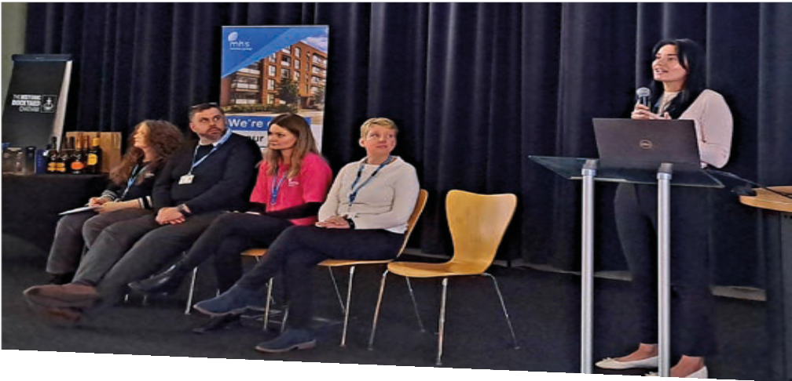





mhs homes newsletter | spring 2025 mhs homes newsletter | spring 2025
4
5




We’re answering your
calls more quickly

“We had to run… run for our lives”

You’ve told us how frustrating it is to wait on hold, and we’ve

been working to improve our call
Win a giant Easter egg
Get ready for a cracking good time! Complete our special Easter crossword puzzle for a chance to win this giant Easter egg. To enter, simply send us a photo
of your completed crossword to newsletter@mhs.org.uk.

We'll choose one lucky winner from all the entries. Don't miss out on this egg-citing opportunity!
Down:
- A baby bird that symbolises new life
- You hunt for these during Easter
- A type of hat often worn at Easter
6. A colourful flower that blooms in the spring
1
2
3
4
Across:
- The animal that delivers Easter eggs
- The season when Easter is celebrated
- What you might use to collect
5
6
7
Easter eggs
7. A sweet treat often found in Easter eggs

to someone. Now, the average wait time is just two minutes – and in many cases, calls are being

We’ve received some positive comments from customers who say they’re really noticing a

In February 2022 Russia invaded Ukraine, causing destruction to its towns and cities and forcing millions of people to leave their homes.

Two of those people were Oksana Pankina and her 12-year-old son.
They got into their car with just a few possessions and fled their
home in the central city of Dnipro.

“I just drove,” says Oksana. “It all happened so fast, we had to run… run for our lives. I can still remember how frightening it felt
to arrive alone in a foreign country where we couldn’t speak the language. That is how our new life in England began.”

In Ukraine, Oksana had studied law and worked as a sales manager. But she realised she had to move on and support her child,
so she began studying English at adult education classes.

“When a flat came up with mhs homes, I couldn't stop thanking the whole world.”
“When a flat came up with mhs homes, I couldn't stop thanking the whole world. It was incredible and fabulous.”

mhs homes teams visited regularly, using a Ukranian interpreter to help Oksana feel more confident and at ease.
“At the most difficult moment of our lives, the team at mhs homes reached out to us. Most
importantly my son and I have our beautiful home.”

Oksana volunteers in a charity shop and sits on the mhs homes Customer Scrutiny Panel. She's continuing with her studies and hopes to get a paid job. Her son has settled at school and joined a local football team.

But she misses the life and the people they were forced to leave behind. “My brother, my father, our friends are still in Ukraine. I worry about them as it’s very dangerous.”

Oksana says she did what she had to do to save her child. “Life is not easy, but it is safe.” 
response times. We’ve restructured and increased our customer service team which means we’re now answering calls faster.
What’s changed?
Over the past year, we’ve more than doubled the size of our Customer Service team and invested in more training. Every new team member has what they need to provide you with the best possible service, from day one.

A year ago, you might have had to wait over 10 minutes to speak
How to get help
Domestic abuse:
answered in under a minute.
Call wait time

January 2024 11:41
January 2025 02:01
We’re proud of how far we’ve come but we know there’s still work to do to give you the best possible service every time. Watch this space for more updates…
difference…

“I called this morning, and my query was answered immediately!
The whole call lasted less than five minutes, and the advisor was amazing! So friendly and helpful. Best experience I’ve had calling mhs homes!”

“I just wanted to say how lovely and helpful you were. Nothing was too much trouble, and you went above and beyond to get my issue resolved.” 


mhs homes newsletter | spring 2025 mhs homes newsletter | spring 2025
6
7
Every mhs homes customer has their own unique story.
difference for your neighbours or in your local community.
We’d love to hear about your experiences with us, whether you’re celebrating moving into your new home, marking an anniversary, or making a
If we publish your story, you’ll receive a £25 voucher. Contact us at communications@mhs.org.uk and we’ll be in touch! 
Do you have a story to share?
No one should have to face domestic abuse alone. Help is available.

If you or someone you know needs support, please tell us. Our team of support workers can offer housing support and advice and talk to you about your options. We also work with other agencies to get the support you need.

Visit our website mhs.org.uk/ domestic-abuse or call us in confidence on 01634 565333. 
and support
Share
your
story

Bring a burst of colour to your home with our spring seeds giveaway!

Spring is here, and what better way to celebrate than by growing your own beautiful geraniums?
Whether you’ve got a garden, a balcony, or a sunny windowsill, these vibrant flowers are easy to grow indoors or outdoors.

Geraniums are not only bright and cheerful, but they’re also low

Housing Ombudsman Service
maintenance and long-lasting. Perfect for adding a splash of colour to your home all year round!

Want to get growing? Order your free seeds today! Just fill in our online form or email us at
springseeds@mhs.org.uk to get yours. 

Tell us how you want to receive your newsletter

The Housing Ombudsman Service is a free service that looks at customer complaints about their landlord.

You can contact them at any time if you’re not happy with something, or for independent advice and guidance.

They will usually only investigate if you’ve already complained to us and we have responded, so please tell us first. We want to put things right if we’ve got it wrong.

If you want to make a complaint, you can fill out a form on our website, call us on 01634 565333 or visit our head office in Chatham.

If you need to contact the Housing Ombudsman, you can do so by:
Telephone: 0300 111 3000
Email: info@housingombudsman.org.uk Website: housing-ombudsman.org.uk

Get in touch

We hope you’re enjoying your newsletter. We’ll send this out to you three times a year in spring, summer and winter.

We’re committed to producing your newsletter in a way that looks after the environment. We use recycled, carbon-balanced paper which is 100% recyclable.
However, if you’d prefer not
to receive a copy through the post, or you’d like to receive it in another format such as large print, please let us know.
Changing your newsletter preferences

Register or log in to My Account and select ‘Profile’ in the menu to change your newsletter preference.

You can choose from the following options:
- Email and post
- Post
- Email
- Don't send (opt out)

If you don't have My Account, email newsletter@mhs.org.uk and let us know your preference.

The email now includes a PDF, Word and plain text version of the newsletter! 




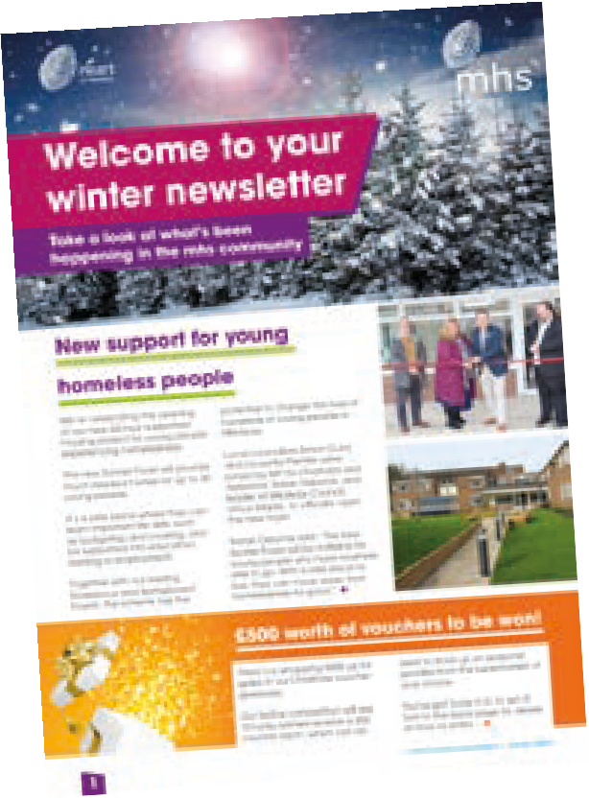
Email contactus@mhs.org.uk or you can call us on 01634 565333. mhs.org.uk mhshomesgroup @mhshomes @mhs_homes

mhs homes newsletter | spring 2025
8

